

**INSTRUCTIONS FOR USE**

**ZOI**

**FARADAY SERIES CEILING PENDANT**

**ELECTRIC SINGLE ARM FOR ANESTHESIA**

**ZOI-CP-FE-1101**

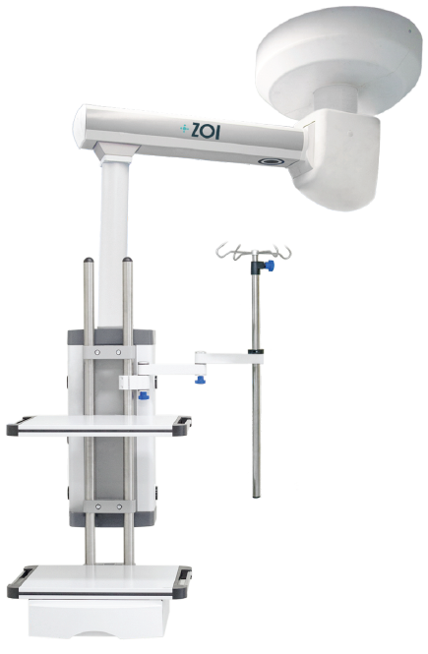

**DISTRIBUTOR** :

THIS MANUAL SHOULD BE PROVIDED TO USERS OF THE PRODUCT.

**USER** :

READ THE INSTRUCTIONS FOR USE BEFORE USING THE PRODUCT. SAVE YOUR USE MANUAL FOR FUTURE REFERENCE.

# **FOREWORD**

Dear Customer,

Thank you for your willingness to purchase the ***ZOI FARADAY SERIES CEILING PENDANT ELECTRIC SINGLE ARM FOR ANESTHESIA****.* This instruction manual sets out all the information about this type for you, including design, dimensions, instructions for use, care, packaging, transportation and storage. You are strongly advised to read this manual carefully before using this product.

Errors in the printing process cannot be avoided. We apologize if there are such errors due to reasons beyond our control. We reserve the right to make modifications without prior notice, and you may find some content that is different from actual product use.

In this case, PT Cahaya Produk Cemerlang Multi Manufaktur will be mentioned as the producer in the next writing and PT ZOI Medisains Indonesia will be mentioned as the distributor in the next writing.

Please contact us if you find any errors in these instructions for use.

**Before using the product, you are advised to:**

1. Make sure that all parts and documentation are packaged before installation. Please contact the distributor or manufacturer if anything is left behind.
2. Before use, please read the attached documents and data carefully and familiarize yourself with the tool. The manual should be retained for future use. The manufacturer and distributor are not responsible for damage to the instrument due to misuse, nor any potential damage thereafter.
3. This product should only be used and/or supervised by Health Professionals.

**GENERAL INFORMATION**

***Table 1 General Information***

|  |  |
| --- | --- |
| **Product Name** | ZOI Faraday Series Ceiling Pendant Electric Single Arm For Anesthesia |
| **Product Brand** | ZOI |
| **Product Brand** | ZOI-CP-FE-1101 |
| **Manufacturer** | PT Cahaya Hasil Cemerlang Multi Manufaktur  Kawasan Industri Delta Silicon 3, Jl Pinang Blok F23 - 15B, Cikarang, Jawa Barat 17530 - Indonesia |
| **Distributor** | PT ZOI Medisains Indonesia  Jakarta Barat, DKI Jakarta 11730 - Indonesia |
| **Edition** | First Edition, 2023 |
| **Revision** | 0.0 |

**KESESUAIAN DECLARATION OF CONFORMITY**

The manufacturer states that this product complies with the following standards :

1. **SNI IEC 60601-1:2014** on Electromedical Equipment - Part 1 : General Basic Safety and Essential Performance Requirements (IEC 60601-1: 2005, IDT).
2. **ISO 14971:2019** regarding the application of risk management to medical devices.

**EXPLANATION OF MARKING**

The following marking symbols are attached to the product label and its packaging,

***Table 2 Symbols for marking product labels and packaging***

|  |  |
| --- | --- |
| **Symbol** | **Explanation** |
|  | Warning notices indicating risk of injury or damage to health |
|  | Read the instructions in the user manual |
|  | Manufacturer |
|  | There is no electrical contact with the user |
|  | Read work instructions before use |
|  | Keep it dry |
|  | Top and bottom position instructions so that the product does not tip over |
|  | Instructions for fragile products and handle with care |
|  | Keep away from sunlight |
|  | Do not turn the product upside down |
|  | Temperature limits |
|  | Hot Surface Warning |
|  | The body of the device must be connected to ground |
|  | Index Protection (Protected from solid objects > 1 mm in diameter, and not protected against liquids) |

**WARRANTY INFORMATION**

This guarantee is only given to original buyers who purchase new/unused products from the designated manufacturer or distributor. This warranty is not extended by any other person or entity and is not transferable or assignable to subsequent purchasers or owners. Coverage in this warranty does not apply to subsequent sales or transfer to another person.

The manufacturer warrants the mechanical and electrical components of this product when purchased new and unused to be free from defects in materials and workmanship for a period of 24 months from the date of purchase from the manufacturer or distributor, with a copy of the bill of sale required as proof of coverage under this warranty. The manufacturer warrants that each product is free from defects in materials and workmanship as long as it is used normally during the warranty period.

The guarantee can be claimed if the damage according to our technician's inspection is caused by a manufacturer error. The guarantee covers labor costs and spare parts.

The guarantee does not apply to the following things:

1. Damage caused by misuse (not following the user manual), misuse and due to natural disasters.
2. This product should only be used and/or supervised by Health Professionals. If the product is damaged because it is used by a user who does not comply with the provisions, then this condition is beyond the responsibility of the manufacturer and distributor.
3. Storage that does not comply with instructions.
4. Damage from unreasonable use.
5. Items and accessories are missing.
6. Do not attach proof/receipt of purchase.

**AFTER SALES SERVICE**

When you need product support:

* For further support please contact the Distributor Hotline (XXXXXXXXXXXXXXX).

Before contacting the Distributor Hotline, please prepare the following information:

* Warranty card
* Proof/receipt of purchase
* Brand/type and product serial number
* Product problems

**SAFETY REQUIREMENTS**

Instructions for use use the following requirements:

1. **Notes**

Read these instructions for use carefully and save them for later use, making sure to make them accessible to other users and observe the information stated in the instructions for use.

1. **Perhatian Attention**

* Only full-time, trained medical staff may use the Ceiling Pendant.
* Before using the Ceiling Pendant, please read this manual carefully and retain it for future reference.
* Ceiling Pendants should not be used in a Magnetic Resonance Imaging (MRI) environment.
* Ambient temperature range +10℃〜+40℃ Relative humidity range 30%〜75% Atmospheric pressure range 700hPa〜1060hPa.

1. **Warning**

* Using a cell phone or other radio frequency radiation equipment near the equipment may cause unexpected or abnormal operating problems. If there is a source of radio frequency radiation nearby, the working condition of the equipment should be monitored.
* Using other electrical equipment on or near this Ceiling Pendant equipment may cause interference.
* Electrical equipment plugged into the 220V AC socket of this equipment (110V AC socket is also available), must not be greater than the rated bus current of this device (≤20A, see the equipment main power label for details). Other electrical equipment connected to this equipment must meet medical electrical isolation safety requirements.
* Do not place objects that do not meet the requirements within 1.5 m of the patient.
* Please do not connect non-medical electrical equipment directly to an AC wall outlet.
* Only AC power from an isolation transformer may be used. Otherwise, under normal conditions and single fault conditions, the leakage current from the outer casing of the Ceiling Pendant equipment may exceed the permitted range.
* May cause electric shock to patient or operator. It's not safe. Once any equipment is connected to these sockets, a complete leak test system is required.
* Operators of medical electrical equipment should not touch non-medical electrical equipment and patients in the hospital at the same time. This may cause an electric shock to the patient or operator.

**INCLUDED IN SHIPPING**

***Table 3 List of Items in Delivery***

|  |  |  |
| --- | --- | --- |
| **No.** | **Item** | **Jumlah** |
| 1. | Instructions for use | 1 pc |
| 2. | Guarantee card | 1 pc |
| 3. | Certificate of Analysis (CoA) | 1 pc |
| 4. | ZOI Faraday Series Ceiling Pendant Electric Single Arm For Anesthesia | 1 Set |
| 5. | Bolts and keys | 1 set |

# **LIST OF CONTENTS**

**KATA** **PENGANTAR** 3

**DAFTAR** **ISI** 7

**BAB** **1 PENGENALAN** **PRODUK** 8

1.1 PENJELASAN PRODUK 8

1.2 SPESIFIKASI TEKNIS 9

**BAB** **2 TATA CARA PEMASANGAN & PENGGUNAAN PRODUK** 11

2.1 TATA CARA PEMASANGAN PRODUK 11

2.1.1. PERSYARATAN DASAR 12

2.1.2. PEMERIKSAAN SEBELUM PEMASANGAN 12

2.1.3. TINDAKAN PENCEGAHAN SAAT DIGUNAKAN 13

2.1.4. GERAKAN HORIZONTAL 14

2.1.5. GERAKAN VERTIKAL 14

2.2 TATA CARA PENGGUNAAN PRODUK 14

2.1.1. HUBUNGKAN CATU DAYA 15

2.1.2. PEMERIKSAAAN FUNGSI PENYALAAN 16

2.1.3. MEMASUKKAN TERMINAL PASOKAN GAS 16

2.3 PENJELASAN & PENANGANAN FUNGSI ERROR 19

**BAB** **3** **PEMBERSIHAN** **DAN** **PEMELIHARAAN** 22

3.1 TATA CARA PEMBERSIHAN PRODUK 22

**BAB** **4 KONSULTASI** **DAN** **PELAYANAN** 24

# **CHAPTER 1 PRODUCT INTRODUCTION**

## **PRODUCT DESCRIPTION**

Ceiling Pendants consist of various types of bases, swing arms or cantilevers, shelves and accessories (as pictured below). The column can provide various gas sources, power sources and information interfaces, as well as provide a working platform for various medical instruments. Ceiling Pendants can move within a certain space to meet usage needs in various directions, so they can provide maximum maintenance. Ceiling Pendants are a necessary additional equipment for accessible medical environments.

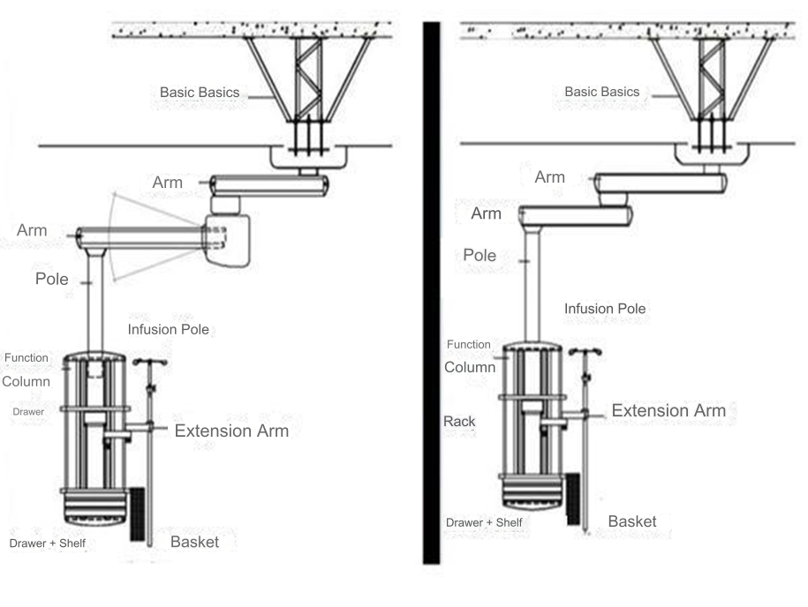

***Figure 1 Product Parts***

***Tabel 4 Product Component Description***

|  |  |
| --- | --- |
| **No.** | **Description** |
| 1. | Basic Basics |
| 2. | Arm |
| 3. | Pole |
| 4. | Function Column |

## **SPESIFIKASI TEKNIS**

***Tabel 5 Spesifikasi Teknis***

|  |  |
| --- | --- |
| **Product description** | ZOI Faraday Series Ceiling Pendant Electric Single Arm For Anesthesia |
| **Type** | ZOI-CP-FE-1101 |
| **Material** | Allumunium alloy & stainless steel |
| **Security Type** | Class 1, Type B |
| **Voltage** | 100 - 240 VAC |
| **Frequency** | 50 Hz |
| **Operating temperature / humidity** | 10°C - 40 °C / 30% - 75% |
| **Storage temperature/humidity** | -20°C - 55°C / < 93% |
| **Product weight** | 270 kg |
| **Rack Load** | Max. 80 kg |
| **Extension Arm Load** | Max. 7 kg |
| **Cantilever Length** | Single Arm 825 mm, customized |
| **Electric arm distance** | 800-1000mm, customized |
| **Turn Angle** | 340° |
| **Braking** | Pneumatic, optional dual braking |
| **Pole Height** | 600 -1000mm, customized |
| **Communication socket** | RJ45 (6 Type) |
| **Shelf Instruments** | 2 layers of shelves, height adjustable |
| **Power Socket** | 220V 50Hz 10A |
| **Gas Terminals** | O2/VAC/Udara/N2O/CO2/N2/AGSS (Optional) |
| **Equipotential Ground** | 2 Port *Equivalent Potential* |

# **CHAPTER 2 PROCEDURES FOR INSTALLATION AND USE OF THE PRODUCT**

## **PROCEDURE FOR INSTALLATION OF THE PRODUCT**

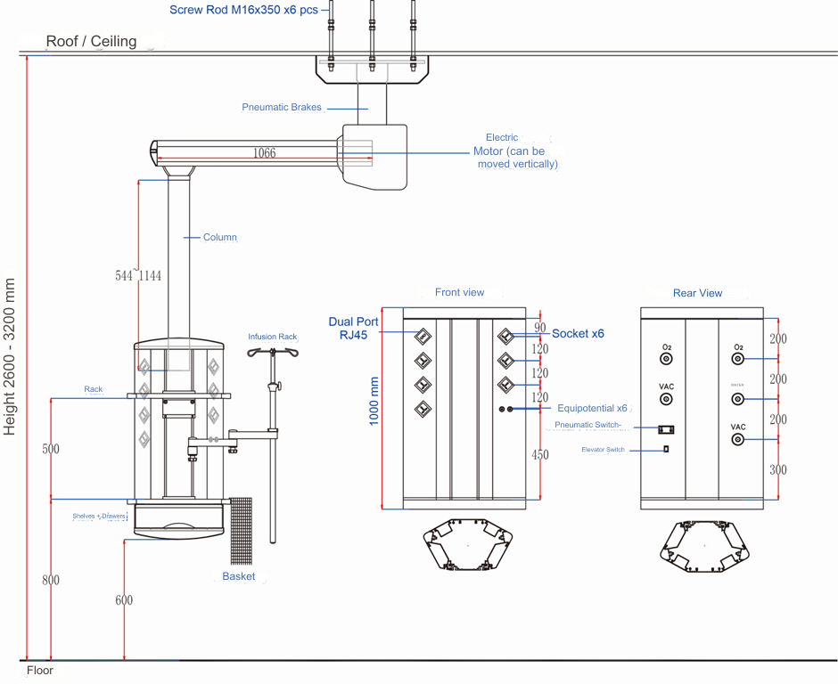

***Figure 2 Product Structure***

## **BASIC REQUIREMENTS**

Ceiling pendant is a tool that can be used to carry medical equipment. Customers need to confirm the following conditions when selecting models:

1. Maintenance instruments and equipment required in the maintenance area;
2. Swing arm, size, weight, and electrical requirements for instruments to be equipped on medical pendants;
3. Type and number of gas outlets;
4. Requirements for Networks, telephones, calling systems, video systems and others.
5. Plan of use locations such as operating rooms, intensive care units, critical areas or examination areas;
6. The air source used as a power source for pneumatic brakes must be greater than 4 kg;
7. Rotating arm combination;

## **CHECK BEFORE INSTALLATION**

Before installing the system, there are several things that must be checked carefully so as to minimize errors during installation:

1. Check whether the inner and outer packaging of the product is complete, whether the spare parts are complete, and whether the markings on the outer packaging are complete.
2. Installation staff must be appointed by our company or properly trained by an installation company professional.
3. After installation is complete, inspection and acceptance must be carried out in accordance with relevant regulations. The following things are considered to pass the acceptance test:
   1. Ventilation or power must be applied to each supply terminal and checked.
   2. Plug each gas terminal socket into the corresponding gas plug, and pass medical compressed air to remove dirt in the pipe.

## **PRECAUTIONS WHEN USE**

Before using the Ceiling Pendant, you need to read the information below:

1. Before use, please make full preparations. You must ensure that gas and electric equipment has passed tests and certificates.
2. Do not exceed the maximum load-bearing capacity of the Ceiling Pendant. Otherwise, it will cause damage to the pendant and even affect the user's personal safety.
3. Don't let the total weight of items on the shelf exceed the maximum loading capacity of the shelf.
4. Whenever you move the ceiling pendant, please ensure the safety of personnel. Collisions caused by braking are not permitted.
5. Do not allow oil or grease, or flammable liquids to contact plug components operating in oxygen (O2) and laughing gas (N2O) environments. And no fires, no smoking in the work area and no use in explosive areas.
6. When you need to connect electrical equipment with something that is not mentioned in the operating instructions, please consult the equipment manufacturer and ask qualified personnel to operate it.
7. However, as long as the equipment has not been serviced or repaired by personnel employed or authorized by the maintenance department or the equipment is damaged due to the operator's failure to operate in accordance with the instruction manual, our Company shall not be liable.

## **HORIZONTAL MOVEMENT**

This pendant is equipped with an air pressure controlled friction brake system (pneumatic brake). Before moving horizontally, release the control air brake. And pay attention to the points below:

1. The rotary operating angle is determined by the brake preset value. The brakes were adjusted when they left the factory. This can be precisely adjusted on site, but must be done by a professional operator.
2. Do not move horizontally when the appropriate pneumatic brake is not released.
3. Release the pneumatic brake button only when the system has reached stall resolution. Otherwise, it may damage the pneumatic brake system.
4. Make sure there are no obstacles within the range of movement.
5. During movement, please ensure that you use force correctly. Hold both sides of the tray to move the Ceiling Pendant. Do not push directly on the edge of the supply column, infusion stand, or other non-load-bearing components.

## **VERTICAL MOVEMENT**

Before controlling the lifting movement, ensure that the movement is within visible distance and that there are no obstacles. The vertical movement of the pendant is controlled by an electric button.

## **PROCEDURE FOR PRODUCT USE**

You need to equip other medical devices below or in front of the user's functional section. And the weight must not exceed the maximum load capacity of the Ceiling Pendant.

## **CONNECT THE POWER SUPPLY**

The power socket and information interface port can be configured into columns according to the actual situation.

1. Connect the medical equipment power plug to the supply column power socket.
2. Connect the equipotential plug to the equipotential terminal (if this configuration is available).
3. Connect the information plug to the information interface port.

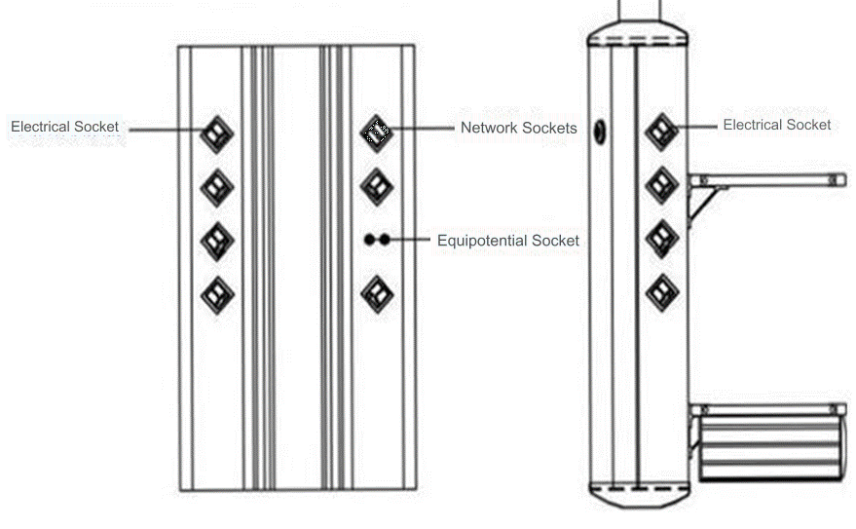

***Figure 3 Struktur Soket Catu Daya***

**Warning：**When users connect other electrical equipment to the 220 V AC socket of the Ceiling Pendant. (110 V AC socket can also be provided), The rated current cannot be above the equipment bus. (≤ 20A, please see the equipment main power label for details). Other electrical equipment connected to this medical equipment must meet medical electrical isolation safety requirements.

**Warning:** The rated current of the power socket is generally 10A. The equipment power plug must have a grounding wire.

## **FUNCTION CHECK**

1. The Ceiling Pendant lifting system works normally, the lifting is stable and normal.
2. Air and brake circuits operate normally.
3. If there is no action after the power is turned on, the professional needs to check whether the power supply indicator in the tower supply column and the power controller is on first.

## **INSERTING THE GAS SUPPLY TERMINAL**

The medical gas supply terminal socket can be configured according to the actual situation located in the column, as shown in Figure 4.

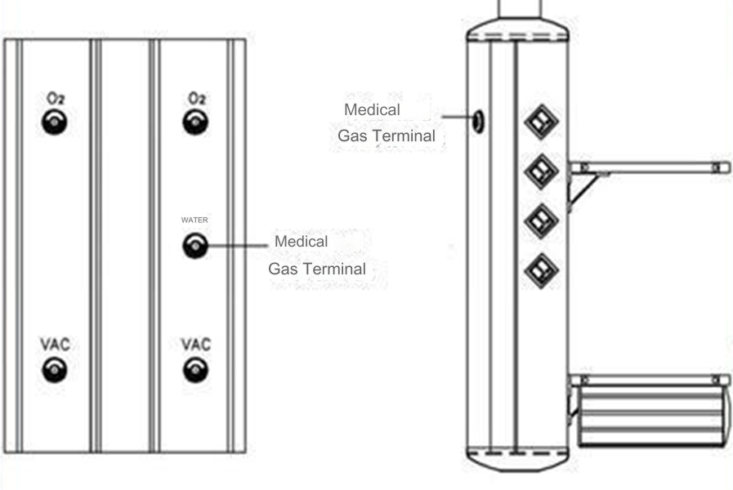

***Figure 4 Medical Gas Socket Structure***

The following figure shows the procedure for installing the gas plug in Figure 5.

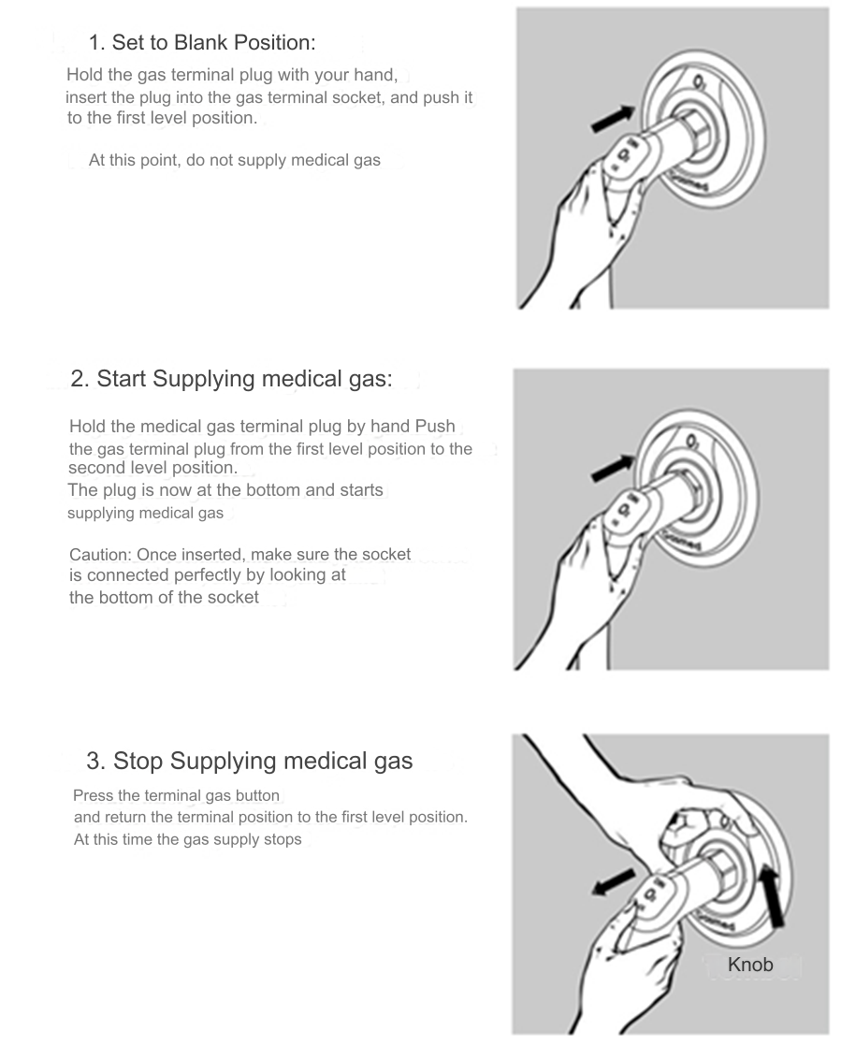

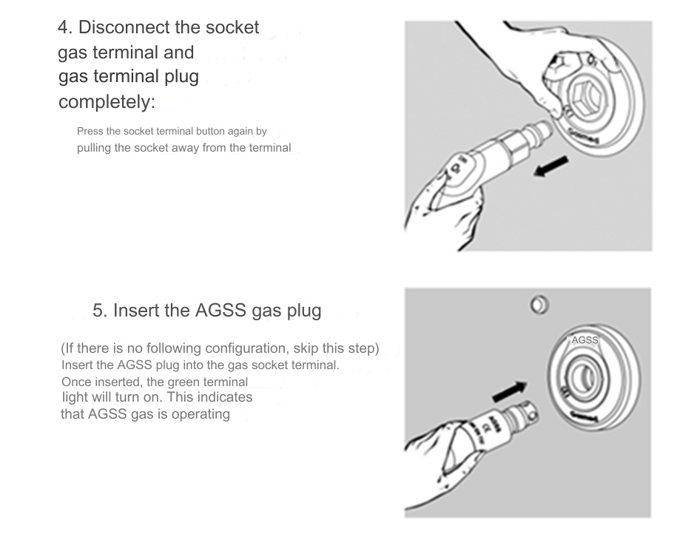

***Figure 5 Procedures for Installing Gas Outlets***

## **EXPLANATION & HANDLING OF ERROR FUNCTIONS**

To handle errors and find out warnings that occur on the product. It can be seen in the following table:

***Table 6 List of Error Messages***

|  |  |  |  |
| --- | --- | --- | --- |
| **No.** | **Problem** | **Cause** | **Correction** |
| 1. | Poor braking effect and Ceiling Pendant deviation | Insufficient air supply pressure | Check whether the gas pressure of the gas pipe is normal, |
| 2 | The gas socket is leaking after being unplugged from the gas outlet | There is no reset device in the gas outlet. | and check in several parts to eliminate errors. |
| 3 | The gas plug is not easily removed from the gas socket | The positioning of the device in the gas socket is not flexible. | It can be restored by repeatedly plugging and unplugging several times with the gas plug. |
| 4 | Insufficient suction at VAC gas socket | The VAC pipe is not smooth. It is indeed blocked; VAC pump malfunction. | Press the release knob on the gas socket repeatedly. Meanwhile, unplug and plug the gas socket several times. |
| 5 | Insufficient suction at the AGSS gas socket | Negative pressure pipe is not smooth and blocked; medical gas supply pressure is insufficient. | Check whether the VAC pipe is clogged and clean it. check if the VAC pump is malfunctioning and troubleshoot. |
| 6 | There is no electricity in the socket | Path failure; | Check whether the negative pressure pipe is blocked, and clean it. It can be examined in several parts; Check whether the medical air pressure strength is normal. |
| 7 | No signal or unstable signal from the power outlet network | The power of the socket is damaged | Observe whether the power indicator lights up. If it's off, there may be something wrong with the equipment path. Errors must be resolved by part inspection. If the power indicator is on and the outlet is not on, the outlet may be damaged. please replace the socket. |
| 8 | There is no signal or unstable signal from the telephone socket | Path failure; the power outlet network is damaged | Troubleshoot network paths piece by piece; Replace the network socket. |
| 9 | There is no signal or unstable signal at the video terminal | Path failure; The telephone socket is broken | Troubleshoot phone lines in parts ; Replace the telephone jack. |
| 10 | Instrument trays or high or low drawers | Path failure; | Troubleshoot video terminals in parts ; Replace the video terminal. |
| 10 | Instrument trays or high or low drawers | the video terminal is damaged | Loosen the screws of the clamp blocks on both sides of the instrument tray with a screwdriver, adjust the upper and lower positions of the instrument tray to a comfortable condition, and then tighten the screws. |
| 11 | The extension arm is too flexible to move with a light touch | Instrument trays or drawers have no suitable place. | Loosen the screws on the clamp block at |

# **CHAPTER 3 CLEANING AND MAINTENANCE**

## **PRODUCT CLEANING PROCEDURES**

The product must be cleaned from time to time. To protect the product from damage, please pay attention to the following:

* + Before sterilization and cleaning, turn off the power supply and medical gas supply first.
  + Use a soft dry cloth or soft cloth to clean the product.
  + Clean the product using medical alcohol or disinfect with ultraviolet light.
  + Store products and components in a clean and safe location.
  + Do not use abrasive or volatile cleaners, benzene, thinners or similar solvents to clean the product.
  + Do not clean the product and any components by immersing them in water.
  + Do not allow liquid to enter gas terminals or electrical sockets.
  + Do not clean the surface of the medical pendant bridge with corrosive solvents.
  + The gas hose in the Ceiling Pendant will oxidize or rust when used. To ensure the safety of the medical suspension bridge, the gas hose must be replaced after the medical suspension bridge has been used for a certain period of time (usually 5 years).
  + To ensure the reliable functioning of the Ceiling Pendant, repair, maintenance and overhaul of the equipment must be strictly carried out by our company's professional operators approved by the company.
  + Changes or modifications not approved by the manufacturer will void the product warranty. Do not disassemble or attempt to repair the product or components.

If you do not plan to use the product for a long period of time, we recommend storing it in the original packaging in a dry place. During storage, do not place any objects on the product. Store the product away from children and remove the battery from the product.

# **CHAPTER 4 CONSULTATION AND SERVICES**

Thank you for your trust in using PT Cahaya Produk Cemerlang Multi Manufaktur products. As a form of concern, we provide product consultation and product repair services.

If you have any questions you can contact us directly for service, please contact :

**Distributor :**

**PT ZOI Medisains Indonesia**

Jakarta Barat, DKI Jakarta 11730 - Indonesia

(Hotline : xxxxx)

**Manufacture :**

**PT Cahaya Hasil Cemerlang Multi Manufaktur**

Kawasan Industri Delta Silicon 3, Jl Pinang Blok F23 - 15B, Cikarang, Jawa Barat 17530 – Indonesia

(Hotline : +62 818-0388-8993)